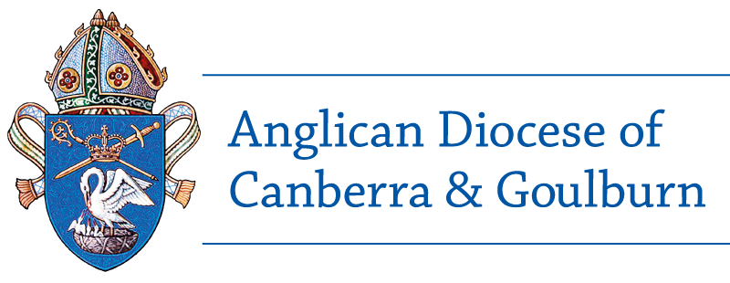
CONFIDENTIAL Safe Ministry Check
Voluntary Church Worker - APPLICANTS 13-17 YEARS

Personal details | Title | Mr Miss Other, specify
 | First name(s)
 | Surname
 | Previous name
 | Date of birth (dd/mm/yy)
 | Gender | male female

Address | Number, Street
 | Suburb/town,
 | State, Postcode

Contact details | Home phone |  | Work phone
 | Mobile phone
 | Email

Confirming your identity | Please attach to this form a clear copy of ONE of the following:  A working with children check, a working with vulnerable people check, your current Australian driver's licence; your birth certificate; a current Australian passport; an Australian citizenship document or Australian immigration papers; a current student identity card from an educational institution; or equivalent form of identification.

Parish, church or organisation
Role applied for

Effective 2 March 2020

1 The Safe Ministry Check

About this form | This form must be completed when a child or young person (ages 13-17years)  is going to undertake pastoral ministry that involves direct, regular and not incidental contact with children.  Ministry to children is defined in the Safe Ministry to Children Canon 2017.  This includes:  - giving spiritual advice and support, education, counselling, medical care, and assistance in times of need that involves direct, regular and not incidental contact with children;  - participating in overnight activities such as camps;  - having close personal contact with children such as changing clothes, washing and toileting.  Roles involving pastoral care include Sunday School teacher, holiday program leader, youth leader, camp helper, overnight activity leader, regular creche assistant, music team leader, worship leader.
To the Applicant | Thank you for volunteering for a ministry role within your church or church organisation.  The Anglican Church is committed to doing everything we can to ensure that our churches and church organisations are safe for all who participate in church activities—including our volunteers. That is why we require everyone who has a ministry role within the church to meet specific standards of personal conduct.  These standards are explained in the Diocesan Protocol for Screening, the Code of Good Practice and the Code of Conduct for Ministry with Children. You should be familiar with these documents and they can be found at Safe Ministry - Policies and Protocols  To help us meet our commitment to safe ministry, we ask everyone who wants to be appointed as a voluntary church worker to answer some important questions. That's the purpose of this form.  Some of the questions are personal and sensitive. We are not asking you these questions because we think you’ve done anything wrong. We ask them because they are part of a process that will help ensure our churches are safe.
Completing the form | 1. Complete all sections.  2. Answer questions honestly. Where required, put a cross [X] in the appropriate box.  3. If you answer 'Yes' to certain questions we may have to ask you for more information. But that doesn’t necessarily mean that you can’t be a volunteer. If there is insufficient space on the form to provide relevant details, please attach a separate page and clearly identify the question your information relates to.  4. Sign your initials at the bottom of every page and sign your full signature at the end.  5. If you are under 16, your parent or guardian must also initial each page and sign at the end.  6. Return to your Parish Safe Ministry Coordinator or the Safe Ministry Unit.
Privacy | This application is confidential.  It will be retained in a secure place by the parish or church organisation in which you are intending to exercise a voluntary ministry. Except as may be required by law, or by church disciplinary procedures, the information you supply will be used only for screening and disciplinary purposes. If required by law, the information you supply will be made available to the applicable authority.

 | Suitability for ministry | Please answer the questions below by putting a cross [X] in the appropriate box.  If you are not sure what is meant by a word or phrase in bold print, please go to the Glossary of term in the Diocesan Code of Good Practice.
- Do you have any health condition(s), which may affect your work with children or young people? |  |  | No Yes If YES, please provide details
- Have you ever been charged with a criminal offence in Australia or in any other country? |  |  | 'Charged' means that the police or other government authority has accused you in writing of committing a criminal offence. Getting a parking or speeding fine is not a criminal offence.  No Yes If YES, please provide details.
- Have you ever been convicted of a criminal offence in Australia or in any other country? |  |  | No Yes If YES, please provide details.
- Have you ever applied for a working with children check or a working with vulnerable people check? |  |  | No Yes  If YES, did the authority to which you applied refuse to issue the check?  No Yes  If NO, was your working with children check or a working with vulnerable people check ever cancelled, revoked or suspended?  No Yes
- Have you ever had a driver's licence? |  |  | No Yes  If YES, has your licence ever been revoked or suspended?  No Yes
- Have you ever had a court order issued against you as a result of someone accusing you of violence, abuse, likely harm, harassment or stalking? |  |  | No Yes If YES, please provide details.
- Has anyone ever accused you of child abuse?  A ‘child’ is a person under the age of 18. Child abuse  includes: harassment, physical bullying, verbal bullying  and cyberbullying; and touching a child in a sexual way  with or without their consent. |  |  | No Yes If YES, please provide details.
- Have you ever produced sexual images of another person under the age of 18? |  |  | No Yes If YES, please provide details.
- Have you ever engaged in sexting? ‘Sexting’ means requesting, sharing, sending or posting online explicit sexual photos, messages or videos. |  |  | No Yes If YES, please provide details.
10. Have you ever been drunk after consuming  alcohol? |  |  | No Yes If YES, please provide details.
- Have you ever used illegal drugs? |  |  | No Yes

2 Record of ministry
In the table below, please list all churches, parishes or congregations, and, if appropriate, church and para-church organisations (such as Scripture Union groups, Crusaders) where you have undertaken ministry as a voluntary worker. We will ask you to authorise them to tell us what they know that's relevant to our assessment of your suitability for ministry in the church.
Church/ Organisation | Location | Role | From (m/y) | To (m/y)

3 Character Reference
Please provide details below of two (2) referees.
In this context, a 'referee' is someone over 18 years of age who is able to give a report on your good character and suitability for ministry among children and young people.
A referee may be a parent or other responsible adult, such as a church leader, teacher or employer, or someone who has known you for longer than one year. Only one referee can be closely related to you.
We will contact your referees to tell us what they know that's relevant to our assessment of your suitability to be a voluntary church worker.
 | REFEREE 1. | REFEREE 2
Title
First name
Surname
Phone
Email
Address

5 Statements
Authority for information |  | I hereby authorise:  - the Anglican Church and its delegates to contact and exchange information with the church organisations, churches, parishes or congregations in the section Record of Ministry;  - every one of these bodies to provide to the Anglican Church and its delegates any information they may have that is relevant to assessing whether I am a suitable person to undertake ministry in the Church; and  - my referees to provide to the Anglican Church and its delegates any information relevant to my application for appointment as a voluntary church worker.
Release from Liability |  | I hereby release from liability any person or organisation that provides information relevant to the assessment of my suitability to undertake ministry in the Church.  I also agree to release the Anglican Church and its delegates from any and all liability as it relates to any investigation by them regarding the information contained in this application, or any action by them as a result of such investigation.
Acknowledgement |  | I understand that any intentional error or omission in the information in this application may prevent me from undertaking voluntary ministry with children in the Church.
Declaration by the applicant |  | I, (insert your full name)  of (insert your full address)  do solemnly and sincerely declare that the information I have provided in this application and the information contained in any documents accompanying this application are true and correct to the best of my knowledge and belief.

Signature of applicant

Date
 | If you are under 16 years of age, either a parent or guardian must sign below.

Signature of parent or guardian if under 16 yrs of age

Date

