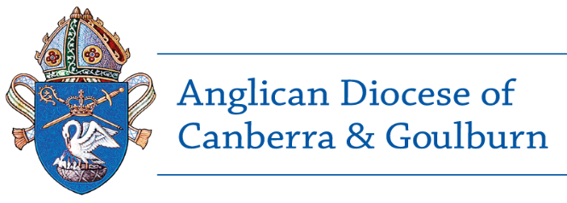
CONFIDENTIAL Safe Ministry Declaration
Volunteers (non-child / vulnerable people role/s)

Personal details | Title | Mr Mrs Miss Ms Other, specify
 | First name(s)
 | Surname
 | Previous name
 | Date of birth (dd/mm/yy)

Address

Contact details | Phone |  | Email

Parish / organisation
Role/s

Privacy Statement
Any personal information you provide is protected under the Privacy Act 1988 and is collected by the Diocese for the purpose of your involvement in a program that operates within the Diocese. It will be kept in a confidential file and used in implementing the Diocesan Screening Protocol. It can only be disclosed to someone else if you have been given reasonable notice of the disclosure; where disclosure is authorised or required by law or is reasonably necessary for the enforcement of the criminal law; if it will prevent or lessen a serious and imminent threat to a person’s life or health; or if you have consented to the disclosure.

Volunteers: Please submit your completed Safe Ministry Declaration to the Rector or Chaplain (or Delegate) of your ministry unit or the Safe Ministry Coordinator.
Paper work will then be sent to the Safe Ministry Unit of the Diocese GPO BOX 1981 CANBERRA ACT 2601

Declaration

I, ____________________________________________________________________________

of, ___________________________________________________________________________

Do solemnly and sincerely declare that:
- The information I have provided in this application and the information contained in any documents accompanying this application and signed by me are true and correct to the best of my knowledge and belief.
- I have received and read a copy of the Code of Good Practice and agree to adhere to the standards in this Code.
- I understand that I will need to attend a Volunteer Induction Session before commencing as a volunteer, and other training as requested.
- I understand that any material misstatement in or omission from this questionnaire may render me unfit to hold a role as a community volunteer in this program.
- I have declared any health problem(s), which may affect my ability to volunteer in the role/s for which I have applied.
- I have disclosed to the Rector, &/or ministry program leader any past criminal charges and/or convictions I have received.
- I have not engaged in the following conduct:
- Engaged in non-consensual sexual activity
- sexual contact with a person under the age of consent
- illegal use, production, sale or distribution of pornographic materials
- I have not ever been the subject of allegations of abuse nor have I engaged in conduct that may result in allegations being made against me of abuse.
Abuse means: bullying; emotional abuse; harassment; neglect; physical abuse; or sexual abuse.
- I consent to the Diocese collecting, using and disclosing personal information as described in the Privacy Statement (on page 1).

APPLICANT’S SIGNATURE
Date: ________________________________________ Signature: ____________________________________
Parish Endorsement
I, ____________________________, priest/authorised representative of the Parish affirm that to the best of my knowledge that the Volunteer applying on the Form is a person of good character. I confirm that they have been provided with a copy of the Code of Good Practice and agree to comply with the standards of the Code.
SIGNATURE OF PRIEST OR AUTHORISED REPRESENTATIVE
Date: ________________________________________ Signature: ___________________________________
* An authorised representative includes the Rector, Priest, Warden, Parish Council Secretary, Ministry Program Director.
The authorised representative should not be someone who is related to the person completing the Safe Ministry Declaration
NOTE: This safe Ministry Declaration remains valid for 3 years, unless circumstances change.

